

Tri-generation System Modifications Spring 2007 Proposal

Tri-Generation System Modifications Spring 2007 Proposal

Group 12:
FSU: Maggie Alvarado, Natalie Levings, and Bruno Vieira
UFPR: Diego Azevedo and Raphael Cavalcanti

Abstract

T
wo groups from Florida State University (FSU) and Federal University of Paranà (UFPR) worked together to develop modifications to a tri-generation system that was built during the 2005-2006 school year.

The tri-generation system previously built achieved its objective of creating electricity, refrigeration and hot water, but was in need of many modifications. One of the problems with the current system is that is it unable to run off of any fuels except gasoline. The refrigerator in the system is an absorption refrigerator. It uses heat from the exhaust to power it. The problem is that the heat source to the refrigerator is constant and needs the controlled heat source to prevent damage of system components. The water-heating unit in the system uses a heat exchanger to transfer heat from the exhaust to the water. In the current design, heat is constantly being supplied to the heat exchanger even though the hot water is not being used. Since there is a constant supply of heat and no demand for hot water, the same water is being continuously heated-up. The final problem with the current system is that the water-heating unit reaches the maximum allowable temperature after 1 hour and 43 minutes of operation and has to be serviced in order to avoid damaging components. These are the problems found by the previous groups who built the system during the 2005-2006 school year.

Both groups have researched the problems stated above and the following describes the proposed modifications. One of the modifications is to allow the system to be able to run off of alternative fuels. The new system will be able to run off of gasoline and compressed natural gas. The second modification is to take advantage of cooling effect of the alternative fuels as they are expanded and to add a second cool space. The third modification is to regulate the temperature in the refrigerator by redirecting the constant supply of heat by means of a valve and bypass system. This bypass system will be automatic and determined by the temperature within the refrigerator. The final modification to be made to the tri-generation system is to only allow heat transfer to the water-heating unit when there is a demand for hot water. All of the exhaust heat will be redirected to a distiller that will be added. This distiller will provide fresh water and will use the heat from the exhaust to distill water.

In order to achieve an optimal design the groups have come up with the following approach. In order to be able to allow the system to run off of two fuels, a conversion kit will be added that allows for gasoline and compressed natural gas to be used. Compressed natural gas (CNG) is stored at a high pressure and must be at a lower pressure when it enters the conversion kit. A regulating valve will reduce the pressure of CNG and expand the gas. As the gas expands, the cooling effect will be used in a second cool space. The heat supplied to the refrigerator will be controlled by a high-temperature valve that will reroute the exhaust gas. The valve will be controlled by an actuator that will be signaled by the refrigerator’s temperature. The exhaust gas that is also normally entering the water-heating unit will also be redirected by a high-temperature valve and bypass piping to a water distiller. This distiller will use the heat from the exhaust to boil water and create clean-drinking water. From all the modifications stated above the tri-generation should operate at optimum conditions.

Introduction

Background
During the 2005-2006 school year a tri-generation system was built that creates electricity, refrigeration and hot water. The system was made of four major subsystems: an internal combustion engine, an absorption refrigerator, a water-heating unit and a generator. This tri-generation system uses wasted heat from the engine’s exhaust to power the refrigerator and water-heating unit. The tri-generation system previously built achieved its objective of creating electricity, refrigeration and hot water, but was in need of many modifications.

Statement of the Problem
One of the problems with the current system is that is it unable to run off of any fuels except gasoline. The refrigerator in the system is an absorption refrigerator. It uses heat from the exhaust to power it. The problem is that the heat source to the refrigerator is constant and needs the controlled heat source to prevent damage of system components. The water-heating unit in the system uses a heat exchanger to transfer heat from the exhaust to the water. In the current design, heat is constantly being supplied to the heat exchanger even though the hot water is not being used. Since there is a constant supply of heat and no demand for hot water, the same water is being continuously heated-up. The final problem with the current system is that the water-heating unit reaches the maximum allowable temperature after 1 hour and 43 minutes of operation and has to be serviced in order to avoid damaging components. These are the problems found by the previous groups who built the system during the 2005-2006 school year.

Overview
The groups brainstormed on each of the modifications that were need and various solutions were found. The conceptual designs were then evaluated based on criteria and then selections were made.

Concept Generation
From the problem statement and design requirements, the group has come up with the following concepts addressing the need for alternative fuels, the need for water management for the water-heating unit and for temperature control for the conduction circuit.

Heat Bypass Conceptual Designs

The prototype will have a heat bypass design to regulate the temperature in the cold space. Currently the prototype supplies a constant supply of heat to the absorption refrigerator. The heat bypass will interrupt the heat flow and allow for temperature regulation in the cold space. An absorption type system does not use a compressor but instead uses a generator.

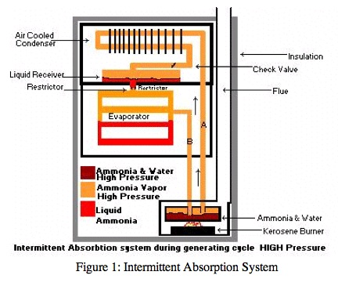
The intermittent absorption system uses a generator charged with water and ammonia. A heat source heats this solution in the generator. The ammonia is vaporized and driven off. A condenser, at the top of the system, condenses the ammonia vapor into a liquid. The liquid flows by gravity into the liquid receiver shown above and then into the evaporator. During the generating cycle, little or no refrigerating effect is taking place. As the system cools, the pressure drops, causing the liquid ammonia in the evaporator to boil (flash off) and absorb heat.
The heat source to the refrigerator is a piece of copper pipe that acts as a conduction circuit. The first design option for the heat bypass modification will consist of a valve and pipe bypass. How this design fits into the current system is shown below in figure 2. The high temperature valve will reroute the exhaust gas before it reaches the conduction circuit. The bypass pipe will route the exhaust gas directly into the heat exchanger. The valve will be controlled by a pneumatic or electronic actuator. An actuator is a piece of equipment that produces movement when given a signal. Actuators are used in the computer control of an environment. The actuator will be signaled by the desired temperature in the refrigerator.

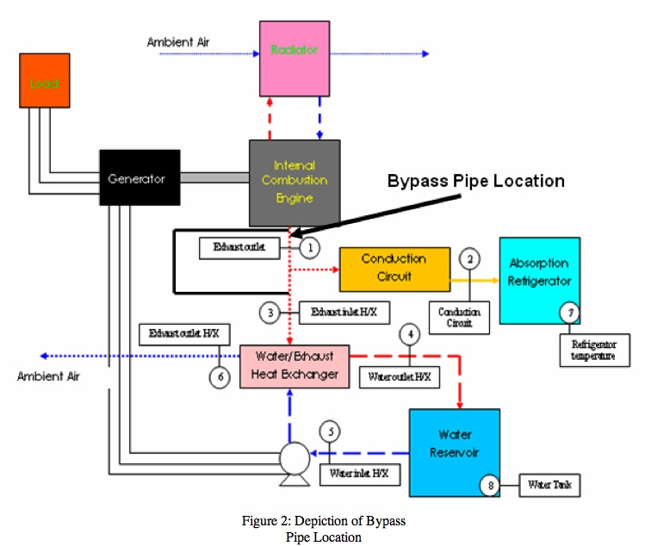
The second design would allow for a physical separation in the conduction circuit. No heat will be conducted from the exhaust gas to the refrigerator. The movement that breaks the conduction circuit will be regulated by an actuator. The actuator will receive a signal based on the temperature in the refrigerator. How this design would fit into the current system is depicted below in Figure 3.

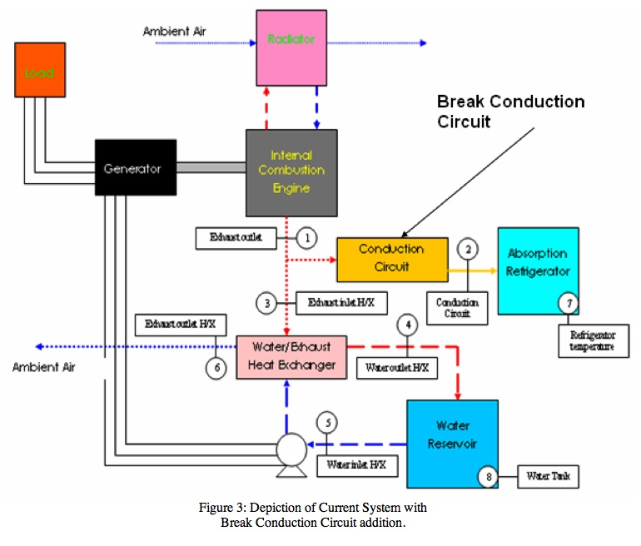

Water-Heating Unit Conceptual Designs

The following conceptual designs were fabricated based on the need for a way to keep the water-heating unit from getting damaged due to the temperature reaching a maximum temperature of 95°C only 1 hour and 43 minutes into the process. The three concepts under consideration are adding an automatic bypass system with distiller addition, adding a water-heating unit bypass with distiller addition and increasing the water reservoir size.

The first concept being considered is an automatic bypass system with an addition of a distiller. This concept is based on a system that would control the heat into both the conduction circuit and the water-heating unit. The excess heat would then be used to generate steam that would be used in a distiller. The modification to the current system is shown below in Figure 4. This concept would help solve two current problems of excess heat to the absorption refrigeration and the water-heating unit. The added distiller would use the excess heat from the exhaust to generate steam.
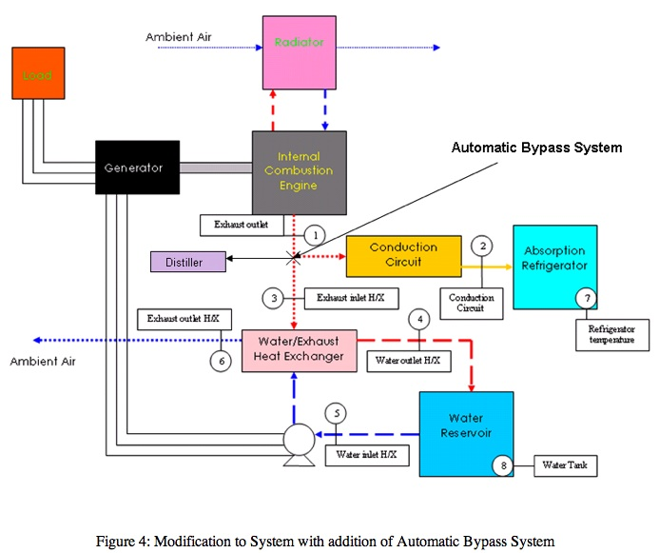
The second concept being considered is one with a water-heating unit bypass and an addition of a distiller. This system involves controlling the heat input into the water-heating unit. The modification to the current system is depicted in Figure 5. The figure depicts the placement of the bypass before the heat from the exhaust reaches the heat exchanger. The heat from the exhaust would go to a distiller and the water-heating unit. The heat to the water-heating unit would also be controlled manually by a valve so water is heated only when needed by the user. This design would prevent overheating of the water-heating unit since the water-heating unit would only be used when needed. All of the waste heat then would be redirected to run a distiller that would provide freshwater.
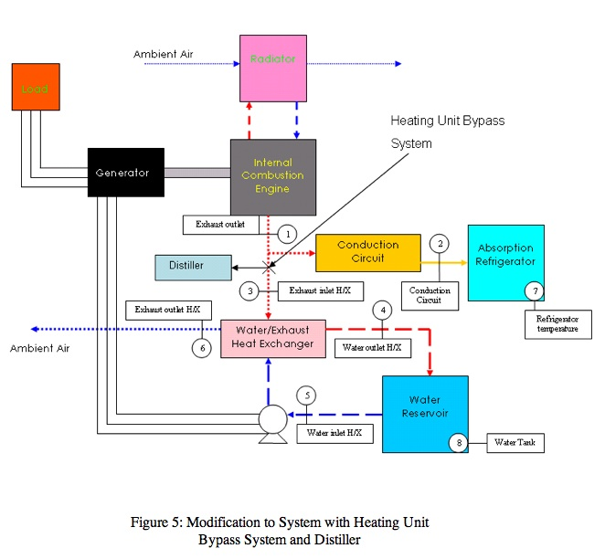
The third concept under consideration involves increasing the size of the water reservoir. The modification to the system is shown in Figure 6 below. By increasing the size of the water reservoir, more heat from the exhaust can be absorbed and overheating would no longer be a problem. Increasing the water tank size though may make the whole unit cumbersome to transport but it would be the most cost effective option.
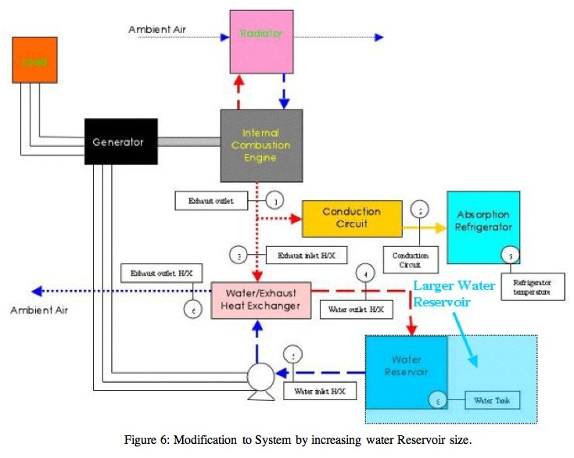
Since two designs involve addition of a water distiller, water distillation should be looked at. In water distillation, water is placed in a boiling chamber and boiled. The water then becomes water vapor and exits the boiling chamber leaving behind impurities. Once the water leaves the boiling chamber is condensed back into a liquid by being cooled in a cooling section and then collected in another container called the collector. One of things that must be taken into account when distilling water is the removal of synthetic compounds (e.g. volatile organic compounds (VOC), pesticides and some volatile solvents) that have a boiling that is lower than water. Since these synthetic chemicals have a lower point than water, they are vaporized and condensed with the water. To avoid having contaminated water, one can use gas vents or a carbon filter. The group decided that a carbon filter would be the cheapest and most simple way to remove these synthetic chemicals.

Alternative Fuels and Expansion Concepts

The engine powering the Tri-generation system is to be converted to run on some alternative fuel in addition to gasoline expanding the system’s capability. Originally, the alternatives being considered were ethanol, hydrogen, natural gas, and propane. The advantages of using alternative fuels are many. All of the options being considered have lower emissions than gasoline. Ethanol has proven to be effective and reliable, with a proven track record as an alternative to gasoline automobiles in many countries.

Regarding the gaseous fuels, natural gas, propane, and hydrogen, the engine life should be increased with the conversion. Lubricating oil life is extended significantly because these fuels do not contaminate and dilute the crankcase oil. The lead effects on the plugs associated with gasoline usage are completely eliminated and plug life is significantly extended.
Hydrogen is the first fuel considered for use. Hydrogen has a high octane rating, 130 compared to 87 of gasoline. Contrary to belief, the danger involved with a rupture in a hydrogen tank is somewhat lower than with gasoline, due to the fact that it dissipates quickly. Although, it is highly explosive and if released in a confined space, it can become extremely dangerous. The main problem regarding hydrogen is that while hydrogen supplies three times the energy per pound of gasoline it has only one tenth the density when the hydrogen is in a liquid form and very much less when it is stored as a compressed gas. For our purposes, it would be used in its gaseous state, requiring very large tanks to store the necessary amount of fuel.
Compressed Natural Gas (CNG) is the second fuel considered. It has long been considered to be an environmentally "clean" alternative to petroleum-based fuels. It is made from compressed methane (CH₄) that has been extracted from natural gas. CNG also has an octane rating of about 130. If handled correctly CNG can produce the same, or more power output from an engine. CNG has four big safety features that make it an inherently safer fuel than gasoline. Firstly, CNG has a specific gravity of only 0.587, meaning it is lighter than air. In case of any leaks, the gas will just rises up and dissipates into the atmosphere. Secondly, it has a self-ignition temperature of 700 degree centigrade as opposed to 455 degree centigrade of gasoline, increasing reliability and efficiency. Thirdly, CNG has to mix air within small range of 4 to 14 percent by volume for combustion to occur, much narrower than gasoline. Overall, CNG proved to be an attractive option from the beginning.
Propane is the third fuel to be considered. Propane has an octane rating of about 104. Unlike natural gas, propane is heavier than air so in its natural state, propane will sink and pool at the floor. It also has a high energy content, 26,900 kJ/L. Propane combustion is also much cleaner than gasoline, though not as clean as natural gas. One thing that makes propane an attractive choice is the fact that it is readily available. It can easily be found in supermarkets, gas stations, and department stores. Ethanol is the other fuel under consideration. In terms of ease of conversion, ethanol initially seemed like the best choice. In terms of physical characteristics, it is the closest of the alternative fuels to gasoline, considering all the other choices are gaseous in nature. In addition, ethanol has been used as an alternative to gasoline for a long time, and recent advances in engine technology have produced vehicles able to run on both gasoline and ethanol without any manual adjustments. It also contains a much higher octane rating than gasoline, about 118. One of the disadvantages of ethanol is that it has a lower energy content than gasoline (about 30% less energy per unit volume). In addition there have been examples of corrosion of ferrous components and formation of salt deposits. The use of ethanol-based fuels can also negatively affect electric fuel pumps, due to increased internal wear and undesirable spark generation.
As work on the project progressed and the objectives were defined it was decided that we would like to add another cool space to the existing system. Considering the fact that the gaseous fuels must be stored at pressures higher than atmospheric and that the pressure must be lowered before inserting the fuel into the engine, we decided that we could use that expansion of the gas to cool the second cold space. That ruled out the possibility of using ethanol. From then on, we focused on the other options, hydrogen, CNG, and propane.
After the types of alternative fuels were selected, it was necessary to analyze the conversion process for each alternative fuel in order to make the best selection. There are three main conversion methods involving gaseous fuels: spud in, adapter, and carburetor replacement.
The kits that use the spud-in method are normally the lowest cost method of conversion, but definitely not the easiest to install. Installation involves physically modifying the carburetor by drilling a hole in it, thus permanently disallowing the use of gasoline by the engine once installed. The carburetor replacement method is simply that. It replaces the gasoline carburetor with a new carburetor containing a correct venturi for the engine and application. These kits give the best consistent power and performance and are the easiest to install. Like the spud-in conversion method, it won’t allow the use of gasoline. Cost and installation time of the adapter method usually fall between the other two methods. The carburetor adapter is installed between the gasoline carburetor and the air cleaner. The adapter method allows dual-fuel operation or it leaves the option of converting the engine back to gasoline in the future. Under full load the adapter method may cause a slight loss of power though, because of the greater air restriction due to two venturis in the system.
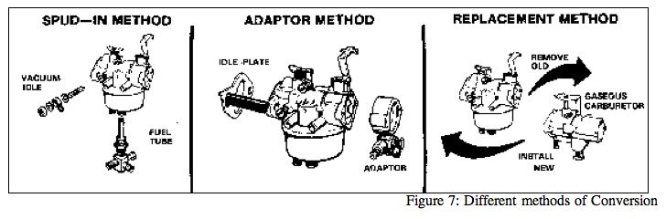
Hydrogen conversion kits are generally more expensive, already adding to the higher cost of the fuel. The kits for CNG and propane both generally work the same way. First, regulators lower the pressure gradually, with the first reduction being the largest one. This first part of the process would be bypassed, with the expansion of the gases to be used to cool a second environment. Once expanded, with its pressure lowered, the fuel would then be introduced into the converter.
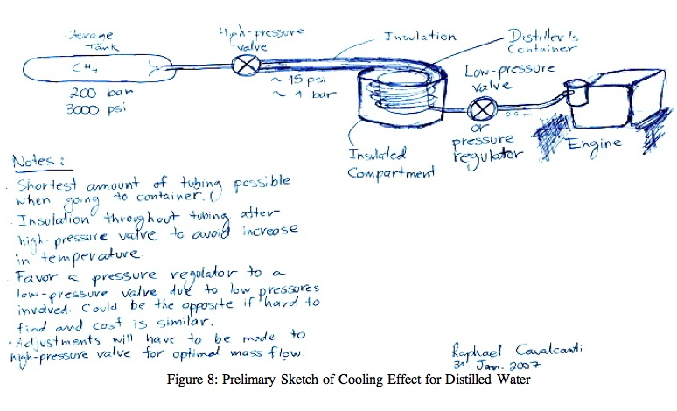
The alternative fuel that will be chosen will be stored at a high pressure. The pressure of the gas must be lowered before it enters the engine. This expansion will produce a cooling effect that will be exploited. It must be noted that the cooling effect of the expanding gas will vary with time; the cooling effect will be most significant in the beginning and will then be less as time passes. The reason for this is due to the fact that as the tank empties, the pressure of the gas will be lowered and pressure difference will be smaller. One of the best ways to exploit this cooling effect could be to create a second cooling space. A concept was devised by both teams to use to cooling effect if in fact a distiller is added to cool the distilled water. Figure 8 shows how this could be done.

Concept Selection

Heat Bypass Design Selection

After considering all of the conceptual designs in controlling the heat to the absorption refrigerator the selection can be made. Based on the problem presented either design should be equally effective which makes the governing criteria cost and physical constraints. Meaning, a conceptual design may be more affordable in theory but may be impractical with the given space constraints. To facilitate the heat bypass effectively and economically a butterfly valve will be used to redirect the hot gas away from the absorption refrigerator’s conduction circuit. The valve will be controlled by a rotary actuator. This actuator will be signaled by the programmed temperature on the refrigerator’s thermostat. Fabrication will be required to make the design more cost effective. Drawings and schematics of the final design are provided in Appendix C-1. The decision matrix used in coming to the conceptual design selection is shown below. All criteria are equally weighted.

 | Cost | Meets Requirements | Ease in adding to current system | Total
Valve and Pipe Bypass System | 1 | 3 | 2 | 7
Break Conduction Circuit | 2 | 3 | 1 | 6
Rank on how well concept meets criteria: 3: great extent, 2: some extent, 1: slight extent, 0: no extent

Water-Heating Unit Conceptual Design Selection
After exploring all of the conceptual designs in controlling the temperature of the water-water heating unit, the selection can be made. Certain criteria must be looked at and how each concept applies it must be taken into consideration. From the problem statement and budget constraints cost, ease into fitting into current system and being able to reduce the temperature from 46 °C to 95 °C are important criteria involved. A decision matrix is depicted below showing how each option ranks according to the criteria.

Decision Matrix
 | Cost | Meets Temperature Specifications | Ease in adding to current system | Safety and Control | Total
Automatic Bypass System | 1 | 3 | 3 | 1 | 8
Water Heating Unit Bypass | 1 | 3 | 2 | 3 | 9
Increasing Water Reservoir Size | 3 | 2 | 1 | 1 | 6
Rank on how well concept meets criteria: 3: great extent, 2: some extent, 1: slight extent, 0: no extent

The first criterion is cost. The cheapest of the three is increasing the tank size of the water reservoir, while both bypass systems with distiller additions are the more expensive options. The second criterion is for the concept to be able to meet the temperature specifications. In meeting the temperature specifications, the water reservoir must not go above the maximum temperature of 95°C. The automatic bypass system with added distiller would meet this criterion by only allowing a limited amount of heat (limited dependent on user’s current need of fresh water or hot water) into the water-heating unit rather than a constant supply of heat. The water-heating unit bypass with added distiller would also meet the temperature specifications since heat would only go to the water-heating unit when the user wanted hot water, any other time, the heat would go to the distiller. For the larger water reservoir size, the temperature specifications would just barely be met with the temperature getting very close to the maximum after three hours. The third criterion is the ease in which each concept is integrated into the current system. Both the automatic bypass system with added distiller and the water-heating unit bypass would be easily integrated into the current system. For increasing the water tank size, this may cause a problem because the tank size would be large and the cart holding the whole system would have to be re-engineered. The fourth criterion is safety and control. Having control over an individual subsystem is important if maintenance is required while the system is in operation. This can also be a safely issue as well. When looking at the automatic bypass concept, there is not individual control over the distiller and water-heating unit. Making the tank larger adds no more control to the system, so it has a low rank for the safety and control criterion. The water-heating unit bypass gives the most control over the system also making it the safest. This concept receives the highest rank regarding this criterion.
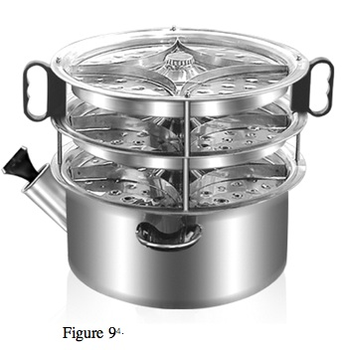
After evaluating how each concept rates with the criteria, the optimal conceptual design is the water-heating unit bypass system with added water distiller.
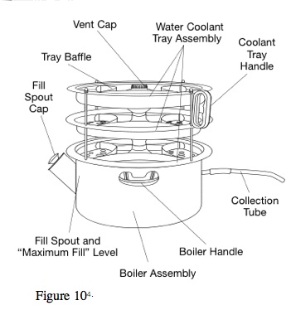
The groups decided to come up with a modification that involves redirecting the heat from the exhaust via a bypass piping to instead heat up water in a water distiller that will produce clean water. The bypass allows all of the heat from the exhaust to go to the distiller and heat only goes to the water-heating unit when the user needs it. The distiller that will be used is the Waterwise Non-electric Water Distiller. It is depicted in Figure 9 and Figure 10. This water distiller is made from stainless steel and can hold 4 liters of water within the boiler.

The distiller that has been chosen has a carbon filter in it cooling section and all of the impurities are removed before being collected in the collector. By redirecting the engine’s exhaust to the water distiller by means of a bypass system, the water-heating unit has been modified so that the water tank does not have to be constantly emptied and refilled while the whole system is working. This modification also takes advantage of the wasted heat and adds another feature to the tri-generation system by distilling water.

Alternative Fuels and Expansion Selection

Looking at each fuel and the necessary conversion kits, the selection can finally be made. Cost, availability and ease of fitting with current system are the most important criteria involved in the decision. A decision matrix assisting in fuel selection is shown below.

 | Ease in Integrating into Current System | Cost | Availability | Total
Hydrogen | 2 | 1 | 1 | 4
Compressed Natural Gas | 3 | 3 | 2 | 8
Propane | 3 | 3 | 3 | 9
Rank on how well concept meets criteria: 3: great extent, 2: some extent, 1: slight extent, 0: no extent

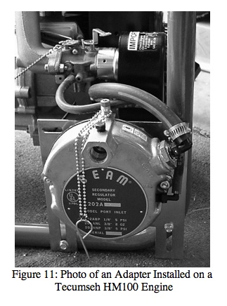
The need for the current fuel to be integrated into the current system is met by all three of the alternative fuel sources under consideration. The second criterion is cost. The high costs outweigh the advantages when it comes to hydrogen. The conversion kits for both CNG and propane are relatively inexpensive, with prices ranging between $150 and $300. The third criterion is availability. As for the decision between propane and CNG, due to the simple fact that propane is more readily available than compressed natural gas, would make it a more attractive option. Looking at all of the criteria, the alternative fuel originally chosen was propane. After further investigation of the expansion process with the teammates in Brazil, it was decided that propane wouldn’t provide enough of a temperature drop during the expansion. Its standard storage pressure is simply too low to make the system work as desired, so a change was made to CNG as it can be stored at pressures of 3000 psi and above.
Once the alternative fuel was chosen, the search for an appropriate conversion kit that fulfils all the requirements was begun. Two companies had conversion kits for the engine; Carb Turbo and USA Carburetion. Prices for both were about the same, $243.75 for Carb Turbo’s and $267 for USA Carb’s. Due to slight price advantage and better customer support, the kit #720-FD501-5 from Carb Turbo was selected. A picture of an adapter is shown in Figure 11.

Conceptual Design Conclusion

In conclusion, the groups have decided on the following conceptual designs. In regards to allowing the system to run off of two fuels, a conversion kit will be added that allows for gasoline and compressed natural gas to be used. Compressed natural gas (CNG) is stored at a high pressure and must be at a lower pressure when it enters the conversion kit. A regulating valve will reduce the pressure of CNG and expand the gas. As the gas expands, the cooling effect will be used in a second cool space. For the conceptual design of a solution for the absorption refrigerator, a bypass system will be installed. A high-temperature valve that will reroute the exhaust gas will control the heat supplied to the refrigerator. An actuator signaled by the refrigerator’s temperature will control the valve. The water-heating unit exhaust gas will also be redirected by a high-temperature valve and bypass piping to a water distiller.

Design Schedule
The groups have broken up the work into work breakdown structures (WBS) that show all of the tasks involved in modifying the tri-generation system. The WBS are shown in Figure 12.

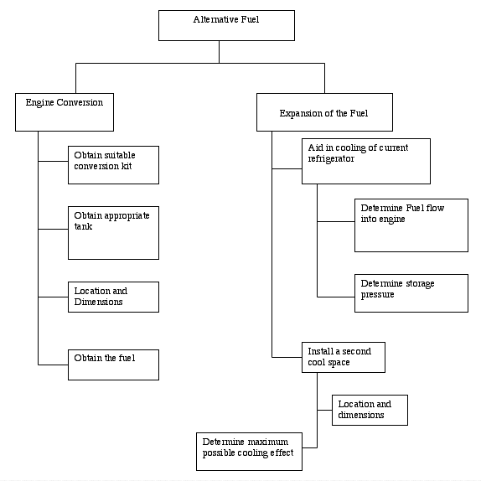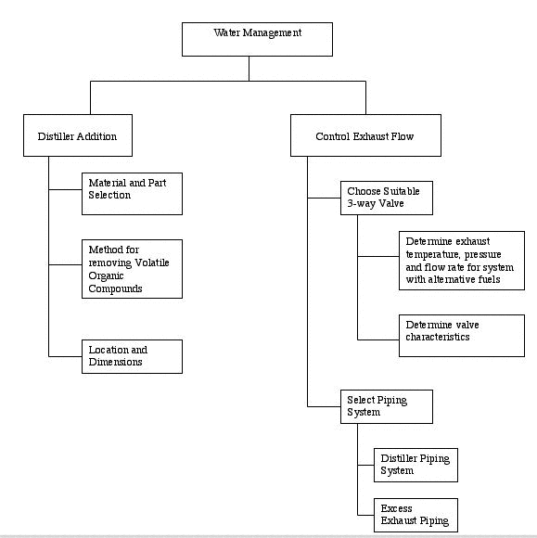
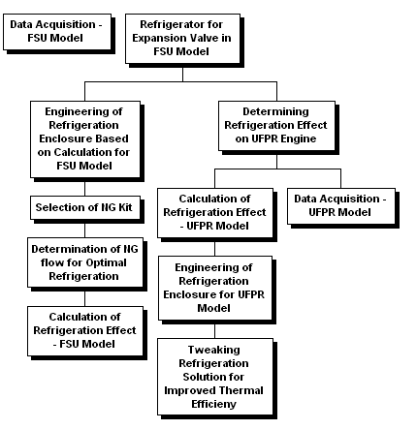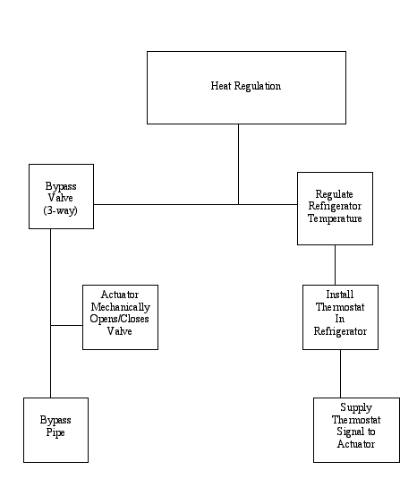
Figure 12: Work Breakdown Structures for each of the major tasks.

Using the WBS’s as a guide, parts will be ordered in mid-December. Following that, stainless steel valves for the bypass systems will be manufactured in January. All modifications will be made to the tri-generation system in late January and all of February. Testing and documentation shall be done in March and April. Thermocouples and flow meters will be used to measure properties of the system using LabVIEW. All results will be recorded and documented into the final report. Below is a Gantt chart, in Figure 13, that depicts the fall schedule.
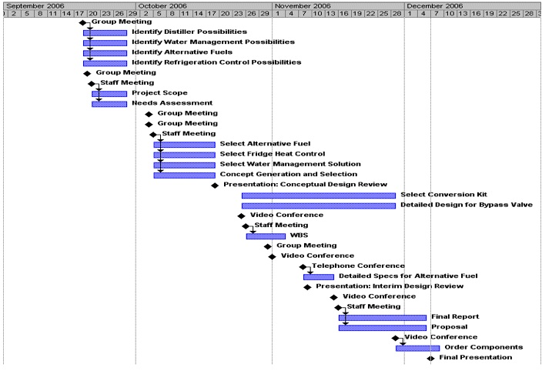
Figure 13: Gantt Chard depicting fall project schedule

The schedule shown also reflects research that has been conducted during the fall semester between the two groups. The proposed Spring schedule, shown in Figure 14, will lead to an end product at the end of March.

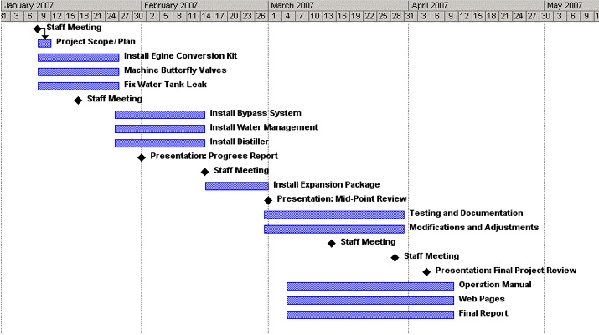
Figure 14: Gantt chart depicting the proposed Spring Schedule.
- Tracy, Thomas Jr., et al. Development of a Tri-Generation System: Final Design Package, Spring 2006. CAPS 1: Integrated Heat Recovery System.
- Tracy, Tom. “Development and First Law Analysis of a Tri-Generation System.
- Çengel, Yunus A. and Robert H. Turner. Fundamentals of Thermal-Fluid Sciences 2nd Edition. New York, NY: McGraw Hill Higher Education, 2005.
- Janna, William S. Design of Thermal Fluid Systems 2nd Edition. Boston, MA: PWS Publishing Company, 1998.
- WaterWise Model 1600 Non-electric Water Purifier/Distiller Use and Care Guide. 2001 Waterwise Inc. www.waterwise.com

 | Component | Sub-Component | Qty | Description | Unit Price | Price
Engine Conversion
 | Conversion Kit |  | 1 | Model # 720-FD501-5 | $243.75
 | Fuel Tank |  | 3 | Model # X8-130 | $389.95 | $1,169.85
Water-Heating Unit | Water Distiller |  | 1 | Model 1600 | $369.00 | $369.00
Piping System |  |  |  | Piping, insulation, valves | $325.00 | $325.00

